WEEK 07 RECONNAISANCE REPORT
Task A: Scope
Student name | Laura Binfa
OSINT case / organization (fictional or instructor-approved) | Axiahub (Axia Technology & Innovation Hub), public website axiahub.ng
Who approved it, and how (e.g. case pack, email) | Instructor, Case pack.
Nmap target permitted (127.0.0.1 or exact assigned target) | Axiahub IP address
Permitted activities / restrictions from instructor | OSINT: public, non-login pages and public sources only. Nmap: localhost only. No scanning, probing or testing of Axiahub or any website.
Date and time of practical work | OSINT collected 2026-10-20. Nmap scan run 2026-10-19 at 06:39

Task B: OSINT Worksheet
No. | Finding and observation | Source and URL | Date collected | Confidence and reason | Limitation | Cross-checked? (Yes/No/Unverified)
F-01 | Courses offered: The Academy page lists three courses with prices: AI Track 2 (AI/ML) at N250,000, Back End Development at N120,000 and Basic Computing at N50,000, each with a 'Join This Class' button. | Axia Hub official website (Academy page) - https://axiahub.ng/academy | 2026-10-20 | High - Official site, page live on collection date. | Prices and courses may change; the page does not show how enrolment is processed. | Unverified
F-02 | Site structure and services: The menu lists Home, About Us, Learn A Skill, Use Our Workspaces, Projects & Initiatives and Other Stuff (Contact Us, News, Gallery, Events, Terms Of Service). A Workspace page is also available. | Axia Hub official website (Workspace page) - https://axiahub.ng/workspace | 2026-10-20 | High - Official site, navigation visible on collection date. | A menu entry shows a page is offered, not that every page works or is current. | Unverified
F-03 | Physical location: Header and footer give the address as Top Floor, Old NITEL Building, Jos, Plateau State, Nigeria. | Axia Hub official website (header and footer) - https://axiahub.ng/academy and https://axiahub.ng/workspace | 2026-10-20 | High - Official source, same address on two pages. | Both pages are the same source, so this is not independent confirmation; address may be outdated. | Unverified
F-04 | Domains in use: The website runs on axiahub.ng, while the contact emails shown use axiahub.org. | Axia Hub official website (address bar and footer) - https://axiahub.ng/academy | 2026-10-20 | High - Visible directly in the address bar and footer. | Using two domains may be normal (e.g. one for web, one for email); this observation alone shows no problem. | Unverified
F-05 | Business contact channels: Hub Line +234 903 520 8470 and Cowork Line +234 911 323 6246 are listed. Footer shows contact@axiahub.org; the workspace header shows info@axiahub.org. | Axia Hub official website (footer and header) - https://axiahub.ng/academy and https://axiahub.ng/workspace | 2026-10-20 | High - Official business contact details shown on two pages. | Two different email addresses appear; this may be intentional. Numbers may be out of date. | Unverified
F-06 | Terms Of Service link not working: A 'Terms Of Service' link appears in the footer and the 'Other Stuff' menu, but the page did not load when tested on 2026-10-20. (Add the exact error or blank page you saw.) | Axia Hub official website (Terms Of Service link) - https://axiahub.ng (add exact link URL) | 2026-10-20 | Medium - Observed once; cause not confirmed. | Could be temporary, a site fault or a problem with my connection. No security conclusion can be drawn. | Unverified
F-07 | No privacy policy found: No privacy policy link was found in the footer or menu on the pages checked (Academy and Workspace). | Axia Hub official website (footer and menu) - https://axiahub.ng/academy and https://axiahub.ng/workspace | 2026-10-20 | Medium - Absence on the pages checked only. | A policy may exist on a page I did not check; this means 'not found on pages checked', not 'does not exist'. | Unverified

Task C: Nmap Results
Target: Axia Hub IP address (172.67.155.107)

Command used: nmap -sT -p 22,80,443 [Target IP]

Nmap version: 7.95

Date and time: 2026-10-19, 06:39

Raw output:
Port | State | Meaning
22/tcp | filtered | No clear reply, usually because a firewall is dropping the probe. Nmap can’t tell if it’s open or closed.
80/tcp | open | Something is accepting connections, and Nmap labels it http.
443/tcp | open | Something is accepting connections, and Nmap labels it https.

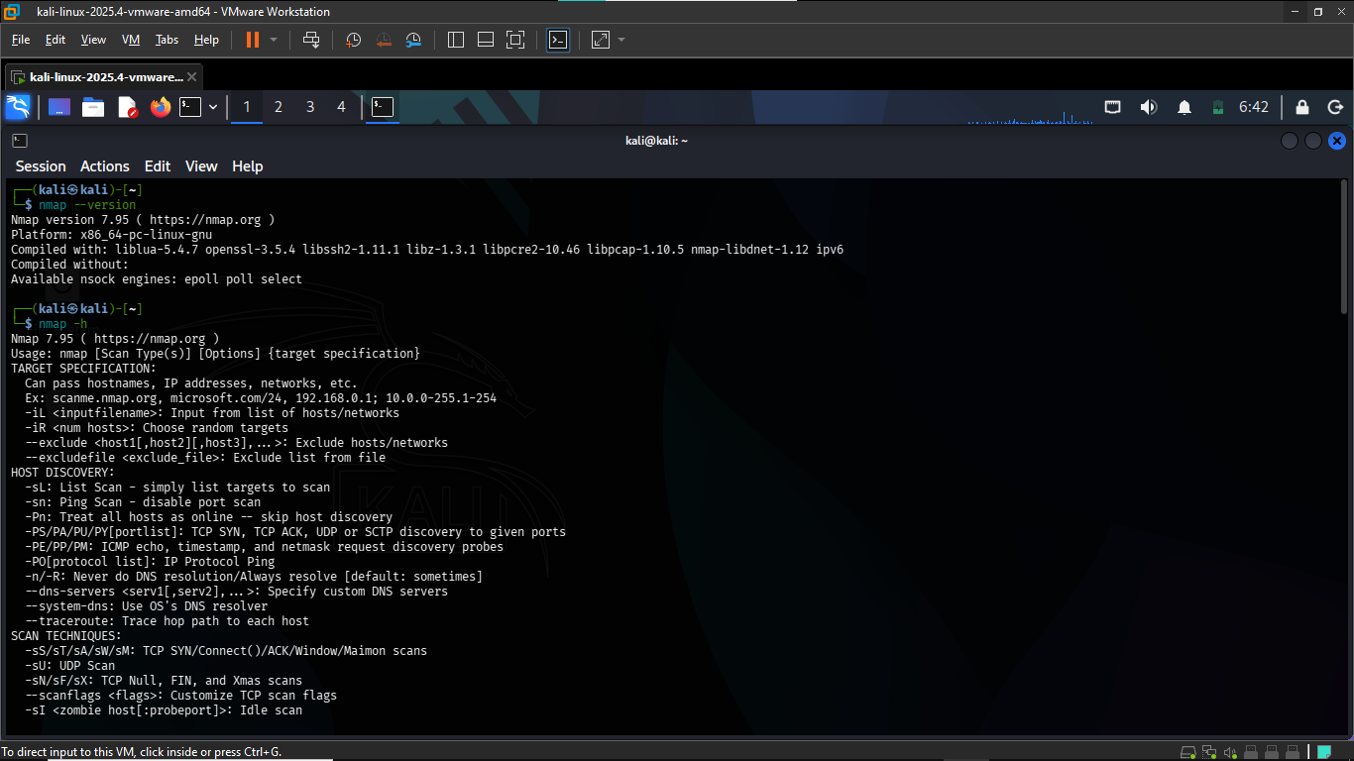

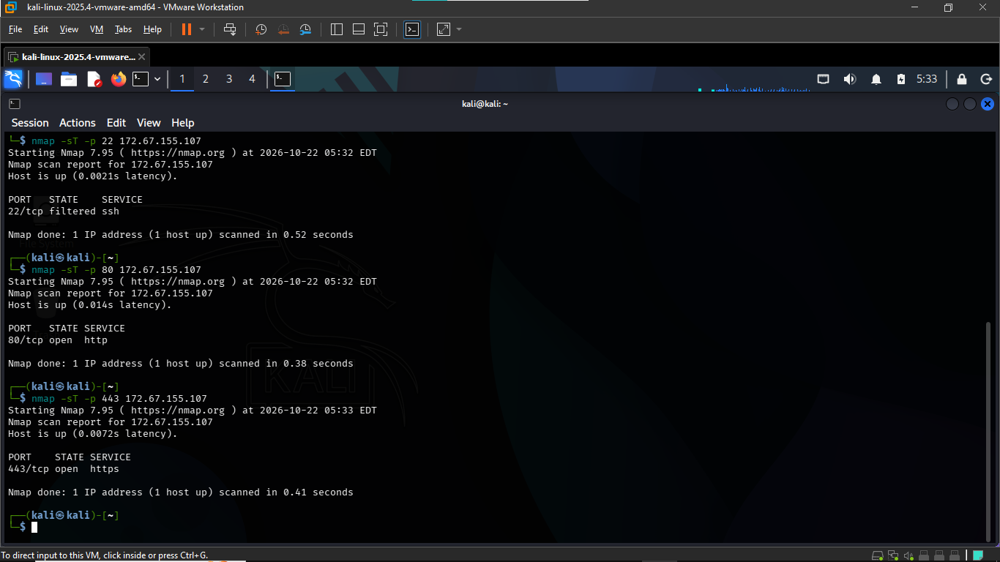

Task D: Interpreting the Nmap Results

1. Responding vs non-responding host
A responding host sends back some kind of reply when probed, even if that reply is a rejection. A non-responding host sends nothing back, so the probe times out. In my scan, localhost replied (“Host is up”, 0.000016s latency), so it counts as a responding host.

2. Open, closed and filtered ports
An open port has a service listening and accepting connections. A closed port is reachable, and the host answers, but nothing is listening on it. A filtered port gives no clear answer, usually because a firewall is dropping the probe, so Nmap can’t tell whether it’s open or closed. In my scan, all 1000 scanned ports were closed because each one replied with a reset. None were open and none were filtered. This displayed a closed port.

3. Detected service vs confirmed vulnerability
A detected service is software that Nmap identifies as listening on an open port, for example a web server on port 80. A confirmed vulnerability is a security weakness that has been separately verified, such as a specific vulnerable version plus a check proving it. Detecting a service is only a lead. In my scan there were no open ports, so no services were detected and there was nothing to assess for vulnerabilities.
4. What this scan cannot prove:
- No open ports does not mean my system is secure.
- Nmap scans only the 1000 most common TCP ports by default, so a service on an uncommon port would be missed.
- UDP ports were not scanned.
- A scan from my own machine only shows how localhost looks from the inside. It says nothing about how the system looks from another network.

Task E: Recommendations and Reflection
Recommendations:
Recommendation 1: Publish a privacy policy and link it in the footer and menu
- Evidence: Finding F-07. No privacy policy link was found on the pages checked (Academy and Workspace).
- Action: Create a privacy policy page and add a link to it in the site footer and the “Other Stuff” menu.
- Reason: The site invites visitors to join classes and contact the hub, which likely involves personal details. A clear policy tells visitors what is collected and why, and supports data protection requirements such as the Nigeria Data Protection Act 2023. This is based on the pages I checked, and a policy may exist elsewhere on the site.
Recommendation 2: Only keep open the ports the website needs
- Evidence: My scan of my own computer (2026-10-19) found all 1000 common ports closed. My scan of Axia Hub’s IP (2026-10-22) found port 80 (web) and port 443 (secure web) open, and port 22 filtered.
- Action: Keep only the ports the website needs open, which looks like 80 and 443. Keep port 22, used for remote login, hidden from the public internet. Run the same scans again from time to time on systems I’m allowed to test.
- Reason: A website needs ports 80 and 443 open, so that’s normal. Port 22 was filtered, meaning no clear reply came back, which often means a firewall is blocking it. Checking again later would show if a new port ever opens by mistake. This only covers three ports, using TCP, on those dates. The IP may also belong to a hosting company (like Cloudflare) rather than Axia Hub’s own server.
Recommendation 3: Fix the Terms of Service link and test links after updates
- Evidence: Finding F-06. The Terms Of Service link in the footer and menu did not load on 2026-10-20.
- Action: Repair the link or page, and test the site’s links after each update, ideally from more than one device or connection.
- Reason: Terms of Service is a page visitors rely on to understand the rules for using the services. The cause of the failure is unknown (it could be temporary), so testing would confirm whether it’s a lasting fault.

Reflection:
OSINT is about gathering information from public sources, while vulnerability confirmation requires separate, verified evidence that a weakness exists. In this project I only collected what Axia hub’s website showed, such as its courses, address and contact details, and I did not claim anything was vulnerable. Even the missing privacy policy and the Terms link that did not load are only observations, because I cannot tell whether they are temporary or whether the content exists on pages I did not check.
The hardest finding to verify was the opening hours. They were not captured in my screenshots, so I had no evidence to show for them, and I could not confirm them against a second source.
Next time I would cross-check every finding with a second independent source, rather than relying on one page of the same website, and I would screenshot each source as I collect it. That would make my findings stronger and easier to defend.

Appendices
Appendix A: Nmap tool evidence (screenshots)
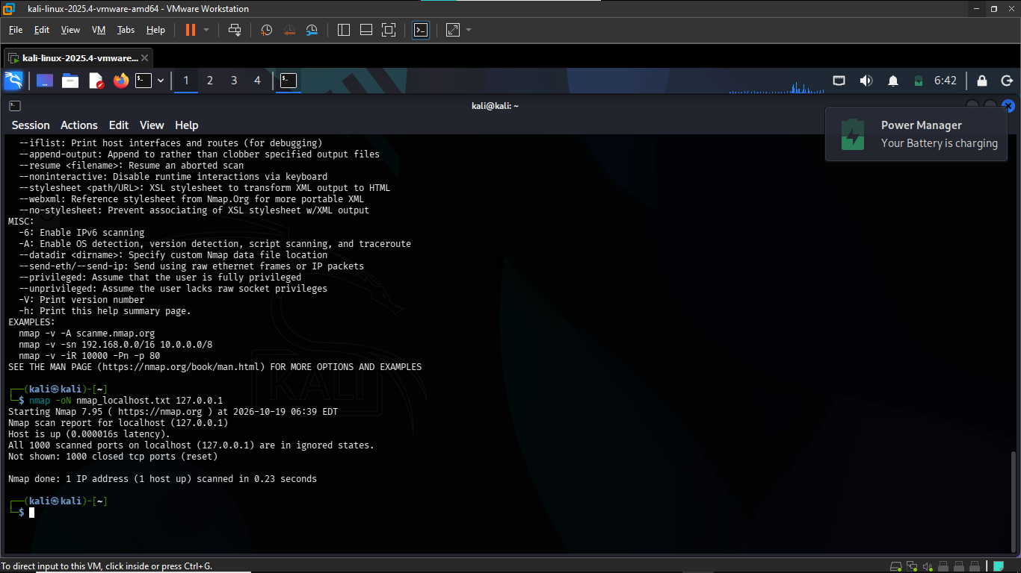

Appendix B: OSINT evidence (screenshots)

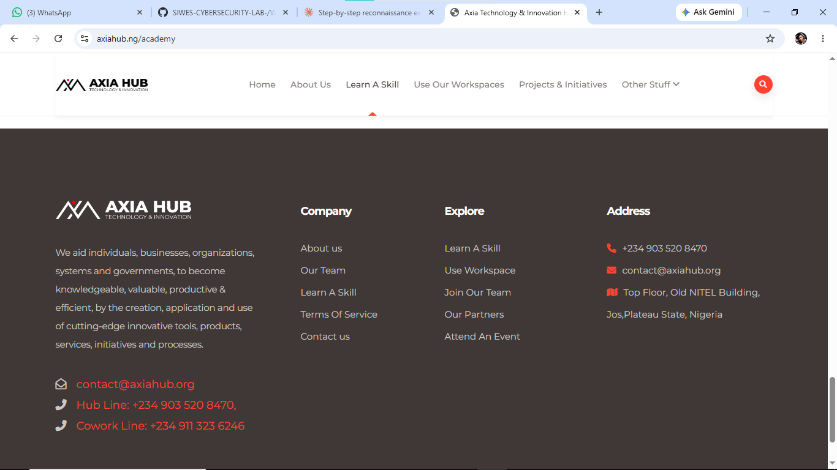

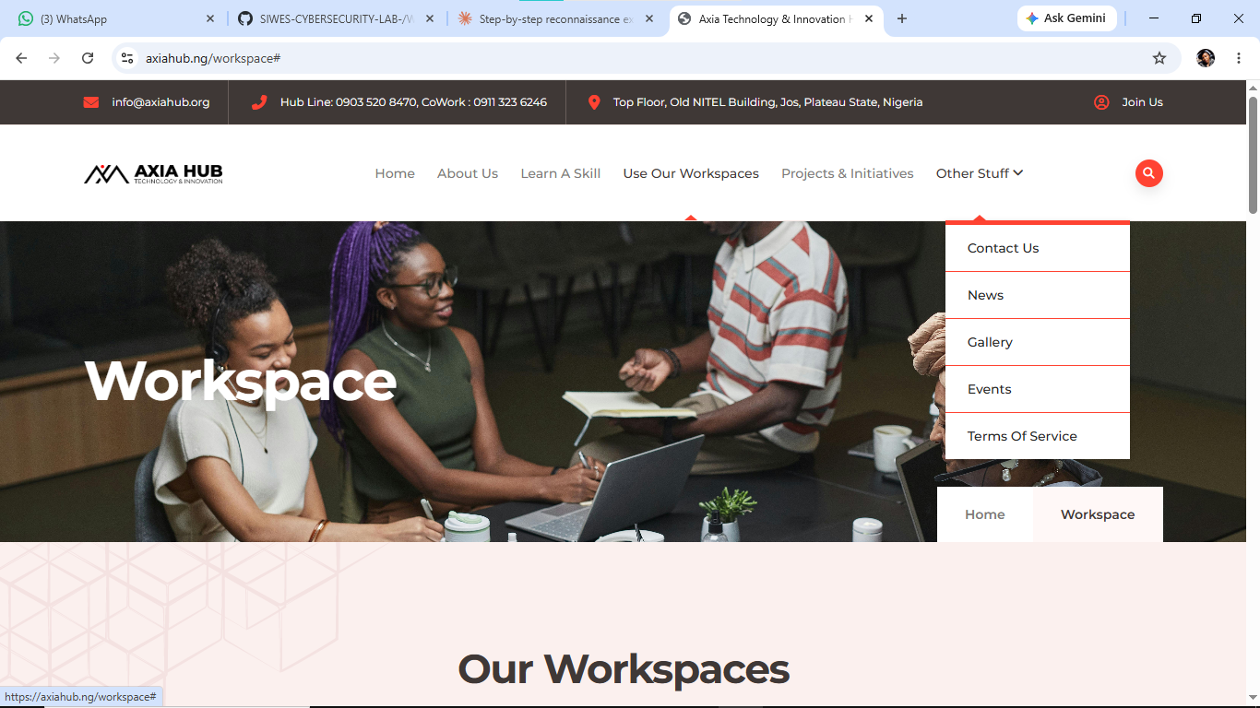

Appendix C: Source references
Ref | Source | URL | Date accessed
S1 | Axia Hub, Academy page | https://axiahub.ng/academy | 2026-10-20
S2 | Axia Hub, Workspace page | https://axiahub.ng/workspace | 2026-10-20
S3 | Axia Hub, footer and header | https://axiahub.ng/academy | 2026-10-20

Appendix D: Raw Nmap output, localhost
nmap -oN nmap_localhost.txt 127.0.0.1
Starting Nmap 7.95 ( https://nmap.org ) at 2026-10-19 06:39
Nmap scan report for localhost (127.0.0.1)
Host is up (0.000016s latency).
All 1000 scanned ports on localhost (127.0.0.1) are in ignored states.
Not shown: 1000 closed tcp ports (reset)

Nmap done: 1 IP address (1 host up) scanned in 0.23 seconds

Transcribed from the terminal output in Figure A3. The same scan was saved by Nmap as nmap_localhost.txt.

Appendix E: Raw Nmap output, Axia Hub IP

$ nmap -sT -p 22 172.67.155.107
Starting Nmap 7.95 ( https://nmap.org ) at 2026-10-22 05:32
Nmap scan report for 172.67.155.107
Host is up (0.0021s latency).

PORT STATE SERVICE
22/tcp filtered ssh

Nmap done: 1 IP address (1 host up) scanned in 0.52 seconds

$ nmap -sT -p 80 172.67.155.107
Starting Nmap 7.95 ( https://nmap.org ) at 2026-10-22 05:32
Nmap scan report for 172.67.155.107
Host is up (0.014s latency).

PORT STATE SERVICE
80/tcp open http

Nmap done: 1 IP address (1 host up) scanned in 0.38 seconds

$ nmap -sT -p 443 172.67.155.107
Starting Nmap 7.95 ( https://nmap.org ) at 2026-10-22 05:33
Nmap scan report for 172.67.155.107
Host is up (0.0072s latency).

PORT STATE SERVICE
443/tcp open https

Nmap done: 1 IP address (1 host up) scanned in 0.41 seconds

